NORTH VANCOUVER PUBLIC ART ADVISORY COMMITTEE
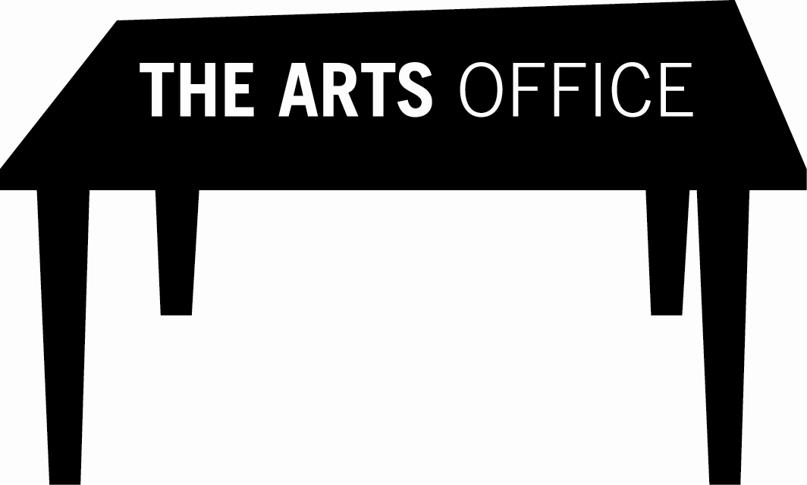
APPLICATION FOR APPOINTMENT

(TERM) January 2014 – December 2015

The North Vancouver Public Art Advisory Committee (NVPAAC) is an expert voluntary body of nine members chosen for their background, knowledge and expertise in the area of public art, architecture, art, urban design, art history or residential development. This bi-municipal committee serving both the City and the District of North Vancouver reviews and advises on public art matters pertaining to the municipally administered civic, community and developer public art programs. Committee members are appointed for a two-year term and are required to attend one monthly meeting. In addition, members may occasionally be asked to serve on a time-limited, project specific, public art selection panel.

Please complete the following form and return to:
The Arts Office
#315 – 1277 Lynn Valley Road., North Vancouver, BC, V7J 0A2
Phone: 604-982-3893 E-mail: info@artoffice.ca

Application Deadline: Friday, December 06, 2013
Name: Date:
Residential Address:
Phone: H: W: Cell:
Email:

NOTE: If you are a current NV Public Art Committee member only fill out #3 & 4.
- Briefly Describe Yourself:
- Why do you want to be on the North Vancouver Public Art Advisory Committee?
- The Public Art Programs for the City and District of North Vancouver are administered through The Arts Office as outlined in their respective municipal Public Art Policy documents. Policy states that The Arts Office will appoint the nine member NVPAAC committee as follows:
  - CNV - Artistic Community Member (artist, curator, educator)
  - DNV - Artistic Community Member (artist, curator, educator)
  - CNV - Urban Design Professional (architect, landscape architect, urban planner)
  - DNV - Urban Design Professional (architect, landscape architect, urban planner)
  - Developer (with a business or resident connection to North Vancouver)
  - CNV Community Member (with a passion for the arts)
  - DNV Community Member (with a passion for the arts)
  - Member at large (NVOCA Rep, or specialized relevant experience)
  - A Member at Large (specialized relevant experience)
Please CIRCLE the number above that best describes the role you can fill on this committee.
- List previous or ongoing community service:
- Outline specific art and/or design experience:
- North Vancouver’s Public Art Collection can be viewed online at www.artsoffice.ca (click on Public Art then Collection). Please provide your opinion on one of the works listed or on the collection as a whole.
List two people who would recommend you for this position: (name, profession, phone #)
1.)
2.)
PLEASE ATTACH RESUME OR CV

